Problem-Solving with Computer
Problem-Solving is a scientific technique to discover and implement the answer to a problem. The computer is a symbol-manipulating device that follows a set of commands known as a program.

Program:
A program is a set of instructions run by the computer to perform specific tasks. The task of developing a program is called programming.

Problem Solving Technique:
Sometimes it is not sufficient to cope with problems. We have to solve that problem. Most people are involved to solve the problem. These problems occur while performing a small task or making a small decision. So, here are some basic steps to solve the problems.

Step 1: Identify and Define Problem: Explain your problem clearly as possible as you can.
Step 2: Generate Possible Solutions: List out all the solutions that you find. Don’t focus on the quality of the solution.
Generate the maximum number of solutions as you can without considering the quality of the solution
Step 3: Evaluate Alternatives: After generating the maximum solution, Remove the undesired solutions.
Step 4: Decide a Solution: After filtering all the solutions, you have the best solution only. Then choose one of the best solutions and make a decision to make it a perfect solution.
Step 5: Implement a Solution: After getting the best solution, implement that solution to solve a problem.
Step 6: Evaluate the result: After implementing the best solution, evaluate how much your solution solves the problem.
If your solution will not solve the problem then you can again start with Step 2
Algorithm:
An algorithm is a set of rules that define how a particular problem can be solved in a finite number of steps. Any good algorithm must have the following characteristics:
- Input: Specify and require input
- Output: Solution of any problem
- Definite: The solution must be clearly defined
- Effective
- Finite: Steps must be finite
- Correct: Correct output must be generated

Advantages of Algorithms:
- It is the way to solve a problem step-wise so it is easy to understand.
- It uses a definite procedure.
- It is not dependent on any programming language.
- Each step has its own meaning so it is easy to debug.

Disadvantages of Algorithms:
- It is time-consuming
- Difficult to show branching and looping statement
- Large problems are difficult to implement

Flowchart:
The solution to any problem in picture form is called a flowchart. It is one of the most important techniques to depict an algorithm.

Advantages of Flowchart:
- Easier to understand
- Helps to understand the logic of the problem
- Easy to draw a flowchart in any software like MS-Word
- complex problems can be represented using fewer symbols
- It is the way to document any problem
- Helps in the debugging process

Disadvantage of Flowchart:
- For any change, Flowchart has to be redrawn
- Showing many looping and branching become complex
- Modification of flowchart is time consuming

Symbols used in Flowchart:

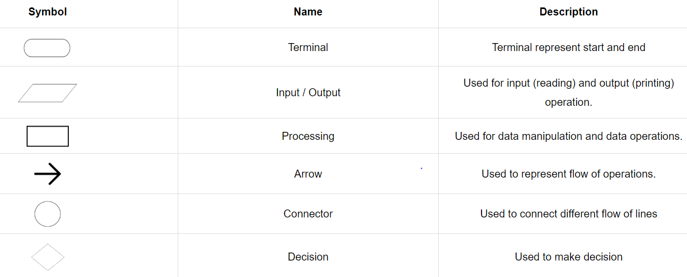

Example: Algorithm and Flowchart to check odd or even
Step 1: Start
Step 2: Declare a variable x
Step 3: Take input from the user and store it in x
Step 4: IF x % 2 == 0 THEN
PRINT Even
OTHERWISE
PRINT Odd
Step 5: End

Flowchart
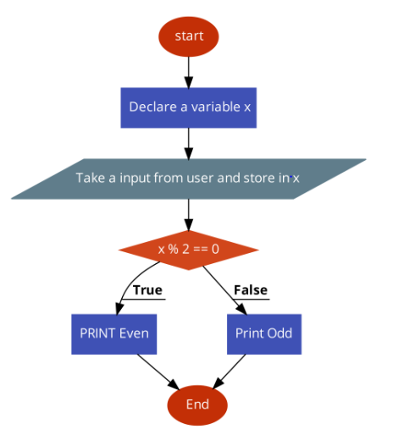

Draw a flowchart to find the largest among three different numbers entered by user.

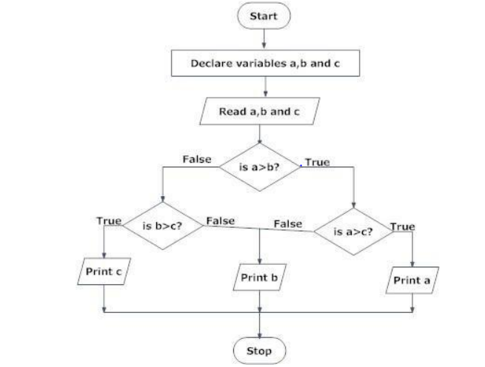
Coding, Compiling and Execution

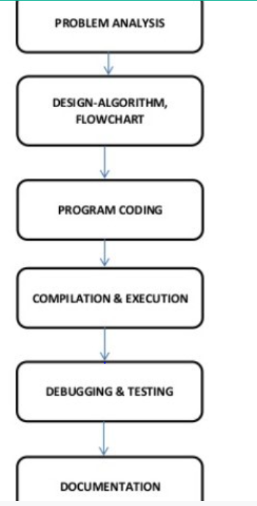

INTRODUCTION TO C LANGUAGE
C is a programming language developed at AT & T’s Bell Laboratories of USA
in 1972. It was designed and written by a man named Dennis Ritchie. In the late
seventies, C began to replace the more familiar languages of that time like PL/I,
ALGOL, etc.
ANSI C standard emerged in the early 1980s, this book was split into two
titles: The original was still called Programming in C, and the title that covered
ANSI C was called Programming in ANSI C. This was done because it took
several years for the compiler vendors to release their ANSI C compilers and for
them to become ubiquitous. It was initially designed for programming the UNIX operating system. Now the software tool as well as the C compiler is written in C.
Major parts of popular operating systems like Windows, UNIX, and Linux are still written in C. This is because even today when it comes to performance (speed of execution) nothing beats C. Moreover, if one is to extend the operating system to work with new devices one needs to write device driver programs. These programs are exclusively written in C. C seems so popular because it is reliable, simple, and easy to use. often heard today is – “C has been already superseded by languages like C++, C# and Java.

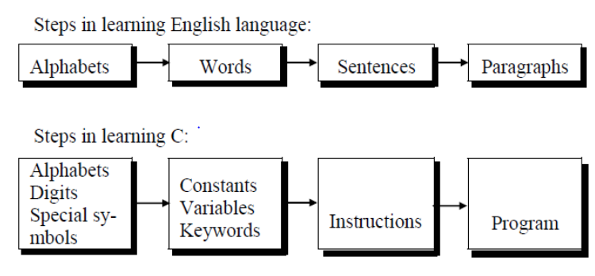

Why c is called the top-down approach?
C programming uses a top-down approach to solve a problem. The top-down approach starts with high-level design and ends with low-level implementation.
In the top-down approach, we use the following approach to solve any problem.
1. First we will make a high-level design of a problem statement.
2. After that we will write the main function.
3. From the main function we will call the sub-functions.
Generally, the large program is divided into small sub-functions (each function will do a specific task) which improves the modularity of a program.
Using that we can easily debug the program.
4. Later we will implement(code) all the sub-functions based on requirements. That's why c is called the top-down approach.

C programming environment setup
For writing and executing the C program we require two things, an editor and a compiler. The text editor is where you write your programs and the compiler translates your text code into a binary stream( 1s and 0s) which the computer understands.
There are four steps attached to the C program these are coding, compiling, running, and debugging (It require when bugs occur). There are many IDE (Integrated Development Environment ) available but here I will describe the Dev-C++.
- Download the setup:
If you don’t have the setup of Dev-C++, then before installing it, you should download the setup of Dev-C++. The good thing is that it is totally free and you don’t need to pay anything (Dev-C++ is Free Software distributed under the GNU General Public License)
https://sourceforge.net/projects/orwelldevcpp/
- Install the setup:
After downloading the setup double-click on it, it extracts the package from the setup and asks to select the language. So select the language as per your choice and press the ok button.
- Accept the license agreement.
- Select the destination folder (keep it to default) and press the install button. It will take a few minutes.
- After completing the installation, Dev-C++ will prompt a window with a finish button. Just press the finish button.
- After pressing the finish button it asks for language and fonts. If you want to change the language and fonts, then you can change.

So as programming language concerns these are of two types.

1) Low-level language
2) High-level language

Low-level language:

Low level languages are machine-level and assembly-level languages.
Machine Level Language:
In machine-level language, computers only understand digital numbers i.e. in the form of 0 and 1. So, the instruction given to the computer is in the form of binary digits, which is difficult to implement instruction in binary code. This type of program is not portable, difficult to maintain, and also error-prone.

Assembly Level Language:
The assembly language is on the other hand modified version of machine-level language. Where instructions are given in English the word ADD, SUM, MOV, etc. It is easy to write and understand but not understood by the machine.

So, the translator used here is an assembler to translate into the machine level. Although the language is a bit easier, the programmer has to know low-level details related to low-level language. In the assembly-level language, the data are stored in the computer register, which varies for different computers. Hence it is not portable.

High-level language:
These languages are machine independent, which means it is portable. The language in this category is Pascal, Cobol, Fortran, etc. High-level languages are understood by the machine. So, it needs to translate by the translator into the machine level. A translator is software that is used to translate high-level language as well as low-level language into machine-level language.

Three types of translators are there:
- Compiler
- Interpreter
- Assembler
A compiler and interpreter are used to convert the high-level language into machine-level language. The program written in a high-level language is known as a source program and the corresponding machine-level language program is called an object program.
Both compiler and interpreter perform the same task but their working is different. The compiler read the program at-a-time and searches the error and lists them. If the program is error free then it is converted into an object program. When the program size is large then the compiler is preferred. Whereas the interpreter reads only one line of the source code and converts it to object code. If it checks error, statement by statement and hence of take more time.

Compiler
The language processor that reads the complete source program written in high-level language as a whole in one go and translates it into an equivalent program in machine language is called a Compiler. Example: C, C++, C#.

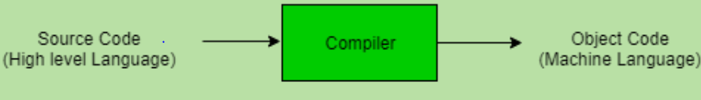
Assembler
The Assembler is used to translate the program written in Assembly language into machine code. The source program is an input of an assembler that contains assembly language instructions. The output generated by the assembler is the object code or machine code understandable by the computer.
We need an Assembler to fill the gap between human and machine so that they can communicate with each other.
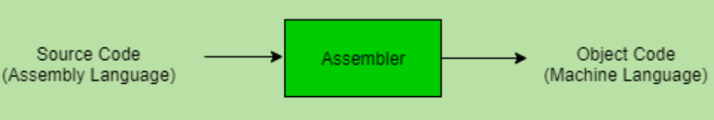
Interpreter
The translation of a single statement of the source program into machine code is done by a language processor and executes immediately before moving on to the next line is called an interpreter. If there is an error in the statement, the interpreter terminates its translating process at that statement and displays an error message.
An Interpreter directly executes instructions written in a programming or scripting language without previously converting them to an object code or machine code. An interpreter translates one line at a time and then executes it.
Example: Perl, Python and Matlab
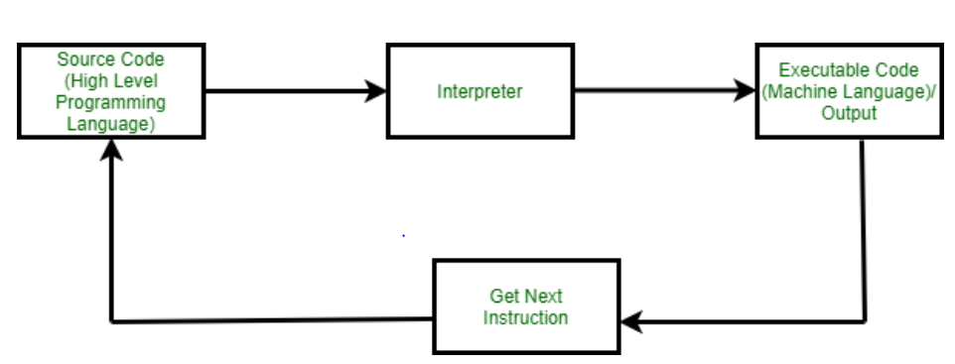

Overview of C
Structure Of C Program
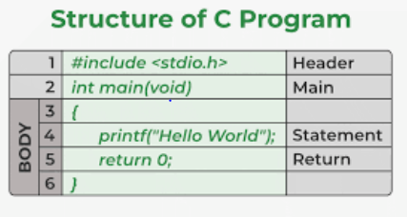

There are 6 basic sections responsible for the proper execution of a program. Sections are mentioned below:
- Documentation
- Pre-processor Section
- Definition
- Global Declaration
- Main () Function
- Sub Programs

Steps involved in the Compilation and execution of a C program:
- Program Creation
- Compilation of the program
- Execution of the program
- The output of the program

